Assignment 01
Mahnoor Shafique
SU92-BSSEM-F25-201
Section : BSSE-2D
Programming fundamental (theory)
Submitted to : Sir Umar Khalil

Program 1: If Else Assignment
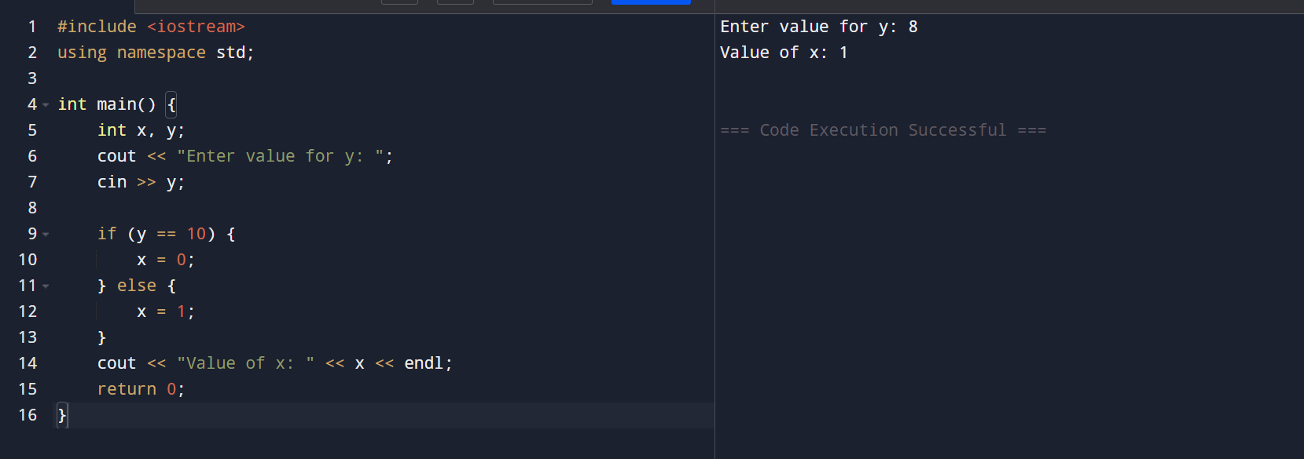
Program 2: Temperature Range Check
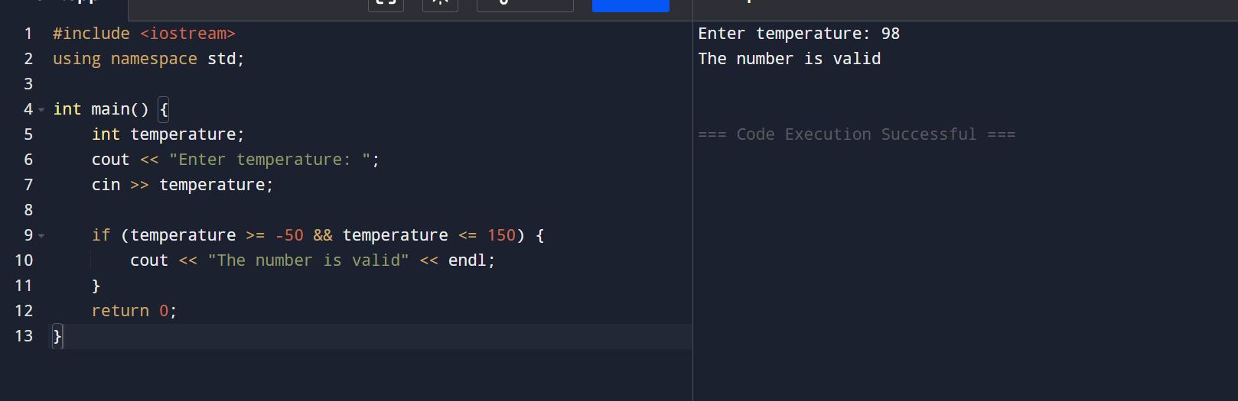
Program 3: Number Comparison
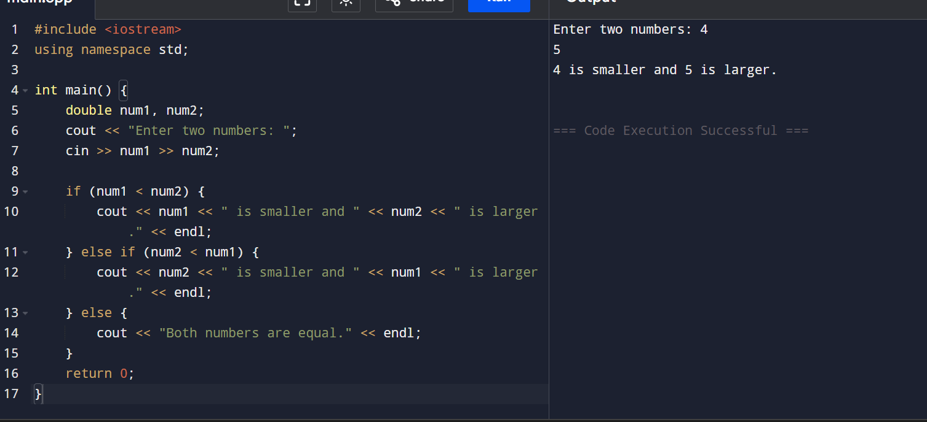
Program 4: Variable Comparison
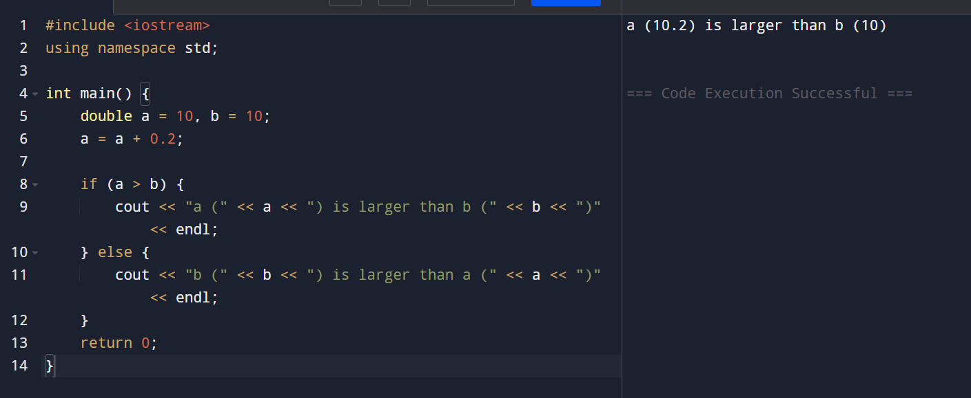
Program 5: Safe Division
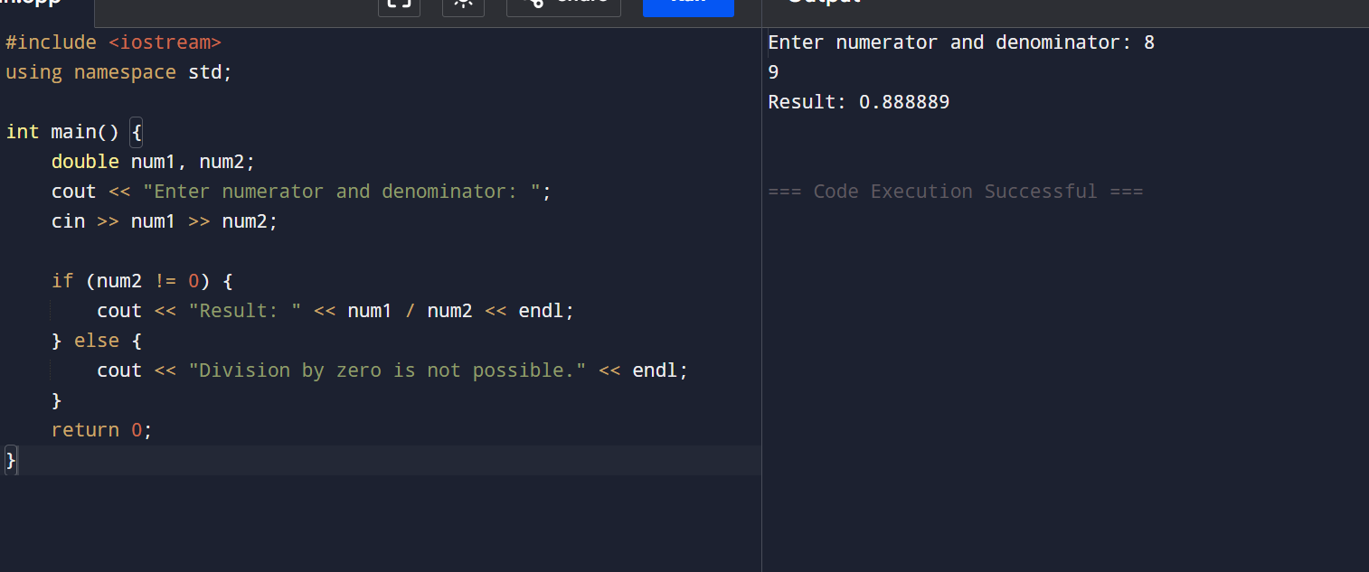
Program 6: Logical Conditions
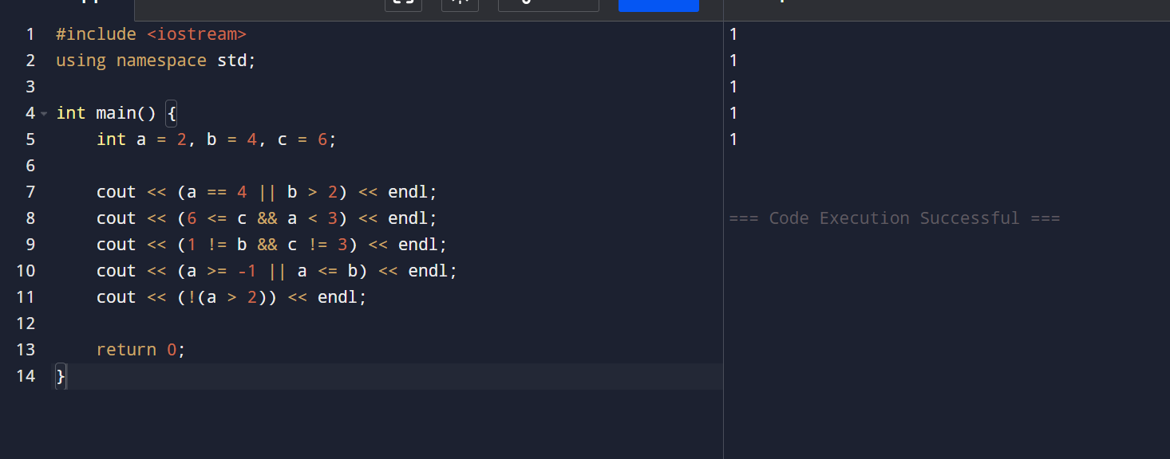
Program 7: Race Results
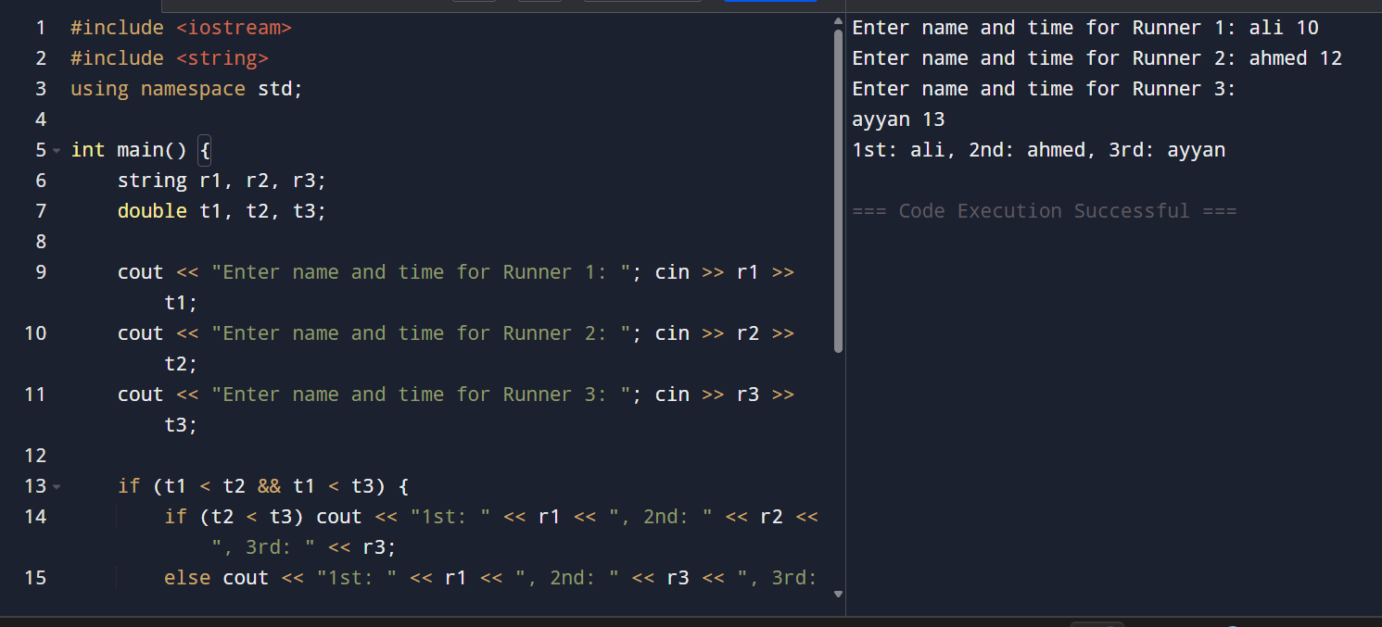
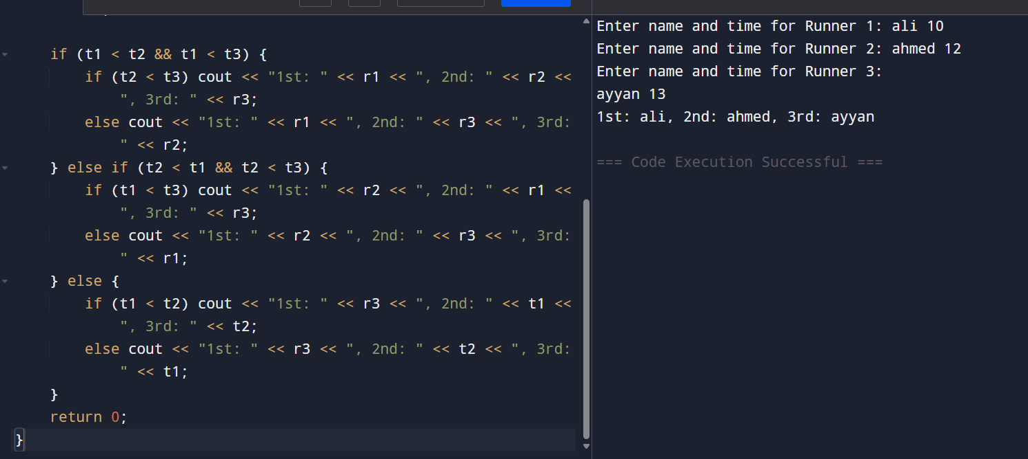
Program 8: Geometry Calculator
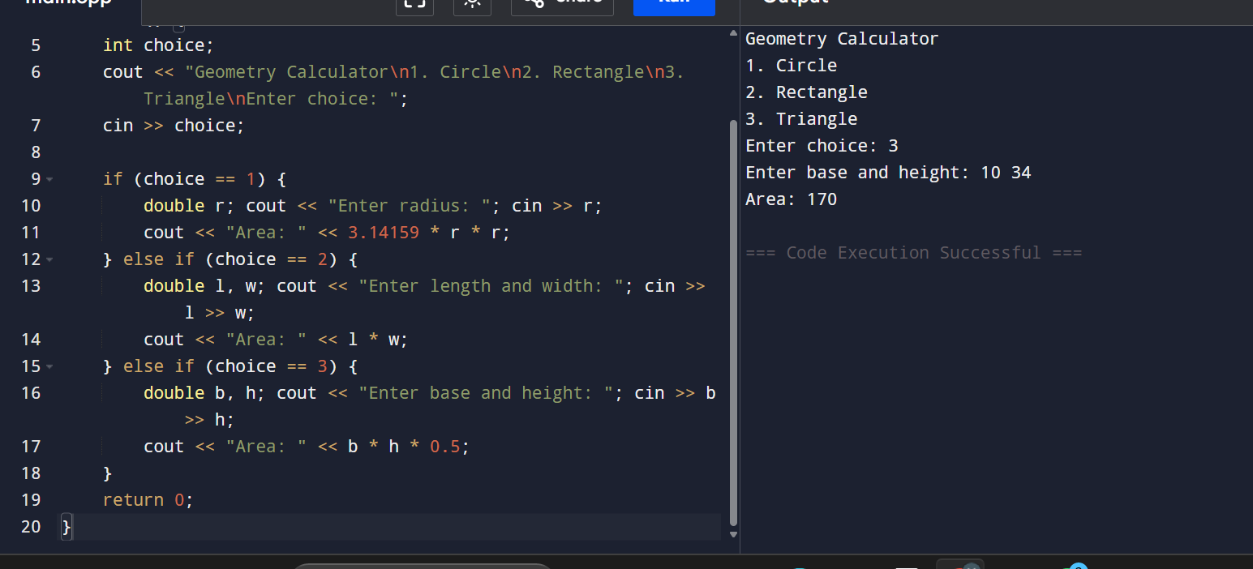
Program 9: ASCII Type Casting
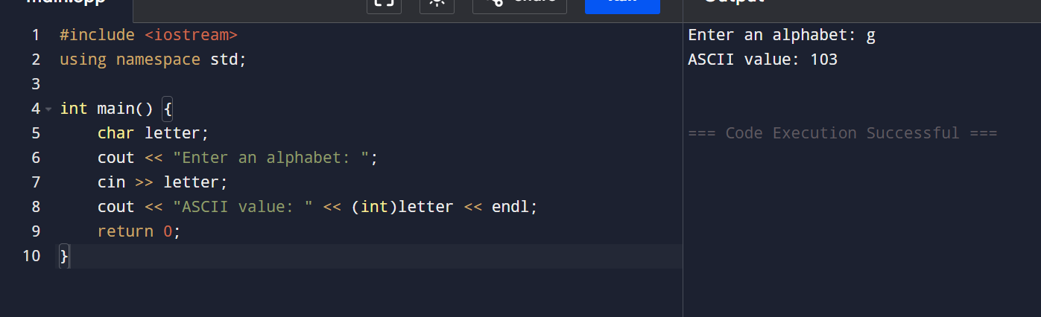
Program 10: Weight & Mass
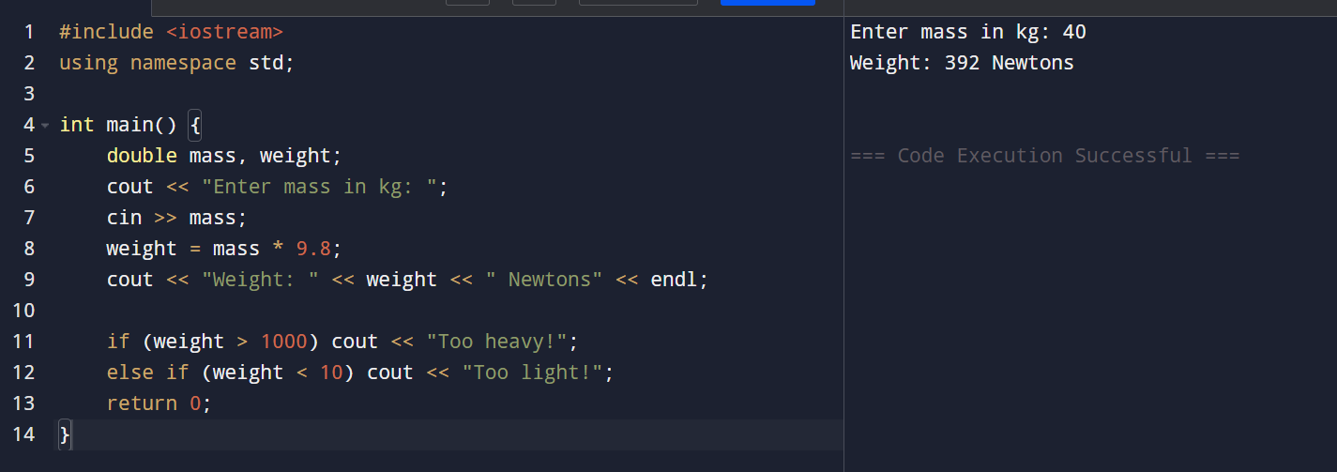
Program 11: Sales Bonus Logic
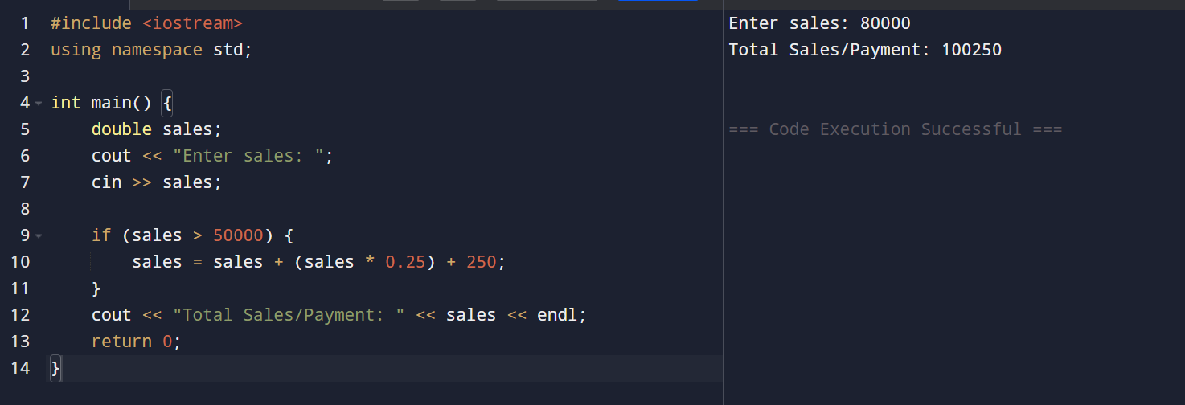
Program 12: Loan Qualification
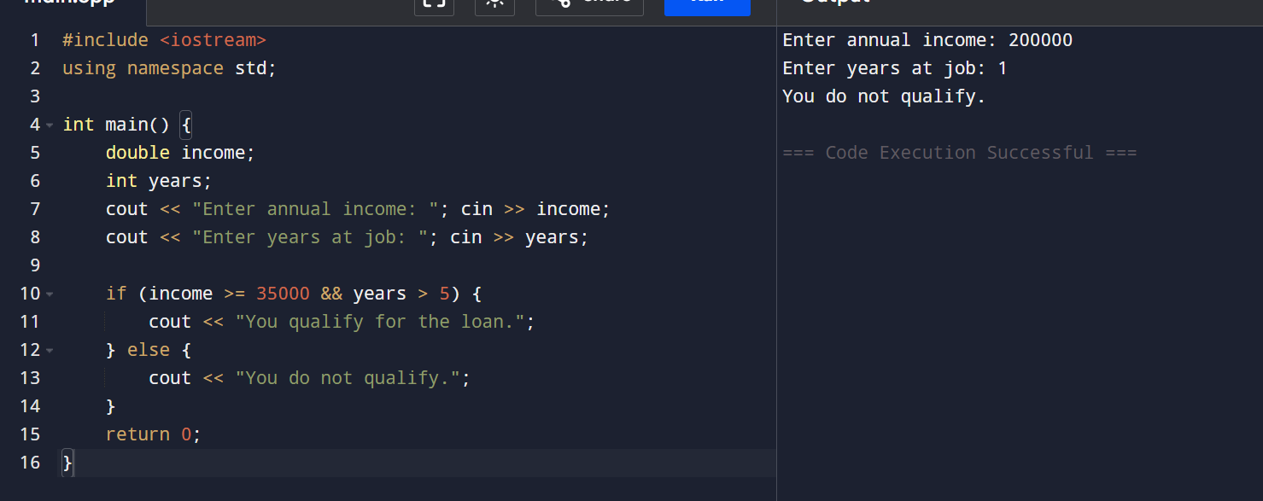
Program 13: TV Features Menu
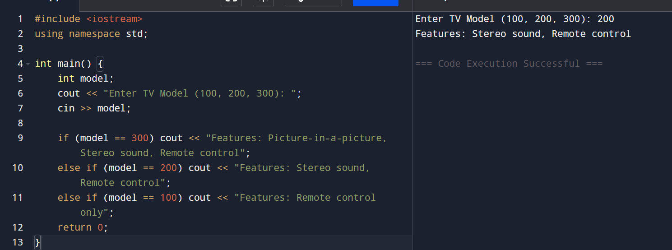
Program 14: Magic Date Checker
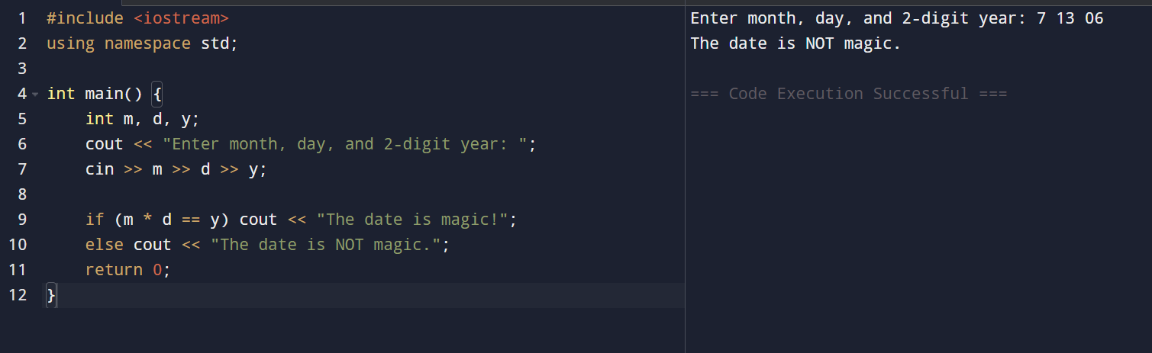
Program 15: Commission Rate
